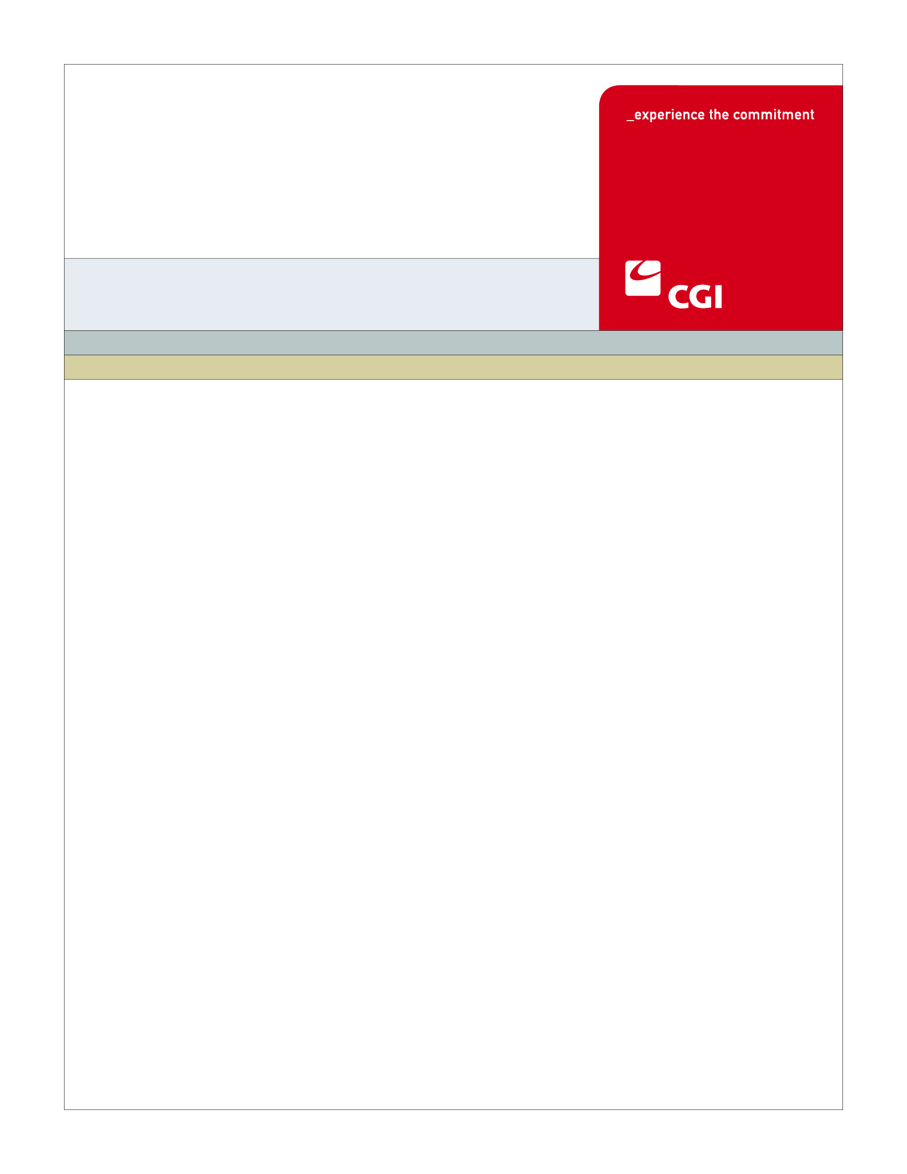3USE

**ELG-006**

**Provide Household Information**

**Use Case**

**Colorado Health Benefit Exchange (COHBE)**

**Version 1.4**

**January 7, 2012**

REVISION HISTORY

|  |  |  |  |
| --- | --- | --- | --- |
| Version | Date | Modified By | Description |
| 0.1 | 11/20/2012 | James Baber | Initial Draft for Discovery Session |
| 0.2 | 11/27/2012 | James Baber | Updated Draft from Discovery Session |
| 0.3 | 11/30/2012 | James Baber | Updated Use Case (Section 5.6.4) to reflect resolved Action Item dealing with checking Incarceration and Citizenship statuses in a shopping scenario. |
| 0.5 | 12/7/12 | James Baber | Updated for Elaboration Session |
| 1.0 | 12/20/12 | James Baber | Updated for Verification |
| 1.2 | 1/2/13 | James Baber | Updated with team comments for verification |
| 1.3 | 1/4/13 | James Baber | Post-Verification Updates |
| 1.4 | 1/7/13 | Jenny Wu | Accepted COHBE updates |
|  |  |  |  |
|  |  |  |  |
|  |  |  |  |
|  |  |  |  |
|  |  |  |  |

TABLE OF CONTENTS

1 Use Case: Provide Household Information 5

1.1 Goal 5

1.2 Brief Description 5

1.3 Requirements Traceability 6

1.4 Primary Actor 6

1.4.1 Individual 6

1.4.2 Employee 7

1.4.3 Broker 7

1.5 Secondary Actor 7

1.5.1 The Exchange 7

1.5.2 OIT Gateway 7

1.6 Pre-Conditions 7

1.7 Successful Post-Conditions 7

1.8 Triggers 8

1.9 Assumptions 8

2 Flow of Event 9

2.1 Basic (Main) Flow – Provide Household Information 9

2.1.1 Is Customer interested in Subsidy Considerations? 9

2.1.2 Request Customer Application Data from OIT Gateway 10

2.1.3 Does Customer Exist in State Systems? 10

2.1.4 Verify and/or Provide Data for Eligibility Determination. 10

2.1.5 Next Steps 10

3 Alternate Flows 10

3.1 Customer Opts Out of Subsidy and State Affordability Programs 10

3.1.1 Pre-Populate Existing Customer Data 10

3.1.2 Provide Data for Shopping 11

3.2 Customer Exists in State Systems 11

3.2.1 Provide Customer/Application Information 11

3.2.2 Update with Existing Customer/Application Data 11

3.2.3 Pre-Populate Data onto Application 11

4 Exception Flows 11

5 Specifications 12

5.1 Business Rules 12

5.1.1 Business Rule 12

5.2 Process Rules 12

5.2.1 Does Customer Exist in State Systems? 12

5.3 Workflow 12

5.3.1 Worklist Definitions 12

5.4 UI Screen Details 12

5.4.1 UI Flow Considerations 12

5.5 Communications 12

5.5.1 Imaging Requirements 12

5.5.2 Form Requirements 13

5.5.3 Notice Requirements 13

5.5.4 Other Communication Requirements 13

5.6 Interfaces 13

5.6.1 Matching Customer in State Systems 13

5.6.2 Baseline SSAp Information Required to Shop the Exchange 13

5.6.3 Single Streamlined Application (SSAp) Data Elements 13

5.7 Reporting 14

5.8 User Security 14

5.8.1 Security Controls 14

5.9 Activity Log and Audit Trail 14

5.10 Data Elements 15

5.10.1 Single Streamline Application 15

6 Future Release Notes 15

7 Appendix A - Glossary 15

# Use Case: Provide Household Information

## Goal

The goal of this Use Case is to have an individual provide the Exchange with detailed information about each person included in the indiviual’s household. This information will be used to determine each household member’s eligibility for Exchange subisides and state affordability programs. It will also be used to identify family members who will be enrolled in Qualified Health Plans (QHPs). This Use Case completes succesfully when the system has the information required to support the Shop for Individual Plan and/or Determine Individual Eligibility Use Cases.

## Brief Description

A Customer will access the Individual Exchange to provide self-attested essential information about their household in accordance with the Single Streamlined Application (SSAp). This information will be used to either:

1. Allow Customers to shop for and enroll in QHPs.
2. Alow Customers to determine their eligibility for subsidies (APTC and CSR) or state affordability programs, and then shop for QHPs.

Information entered by the Customer will follow the guidelines of, and be entered into, the SSAp. Customers opting out of subsidy considerations and seeking only to shop for and enroll in a QHP will be required to enter baseline SSAp information (Section 5.6.3) to support the shopping experience. Customers seeking to apply for subsidies or state affordability programs will be required to provide the Exchange with additional SSAp information to support eligibility processes (Section 5.6.4). If the Customer is eligible for the Cost Sharing Reduction (CSR) or Advance Premium Tax Credit (APTC) subisdies, QHPs will be displayed with premium costs reflecting the subsidies the Customer is eligible for. Additionally, if the user is shopping for a family that has mixed eligibility, the Exchange will present state affordability programs for which household members are eligible in addition to Qualified Health Plans (QHPs).

## Requirements Traceability

The following requirements are covered within this Use Case:

* GF071: The SHOP and Individual Exchange shall obtain SSAp data from State Gateway such that where applicable the data element is pre-populated so that a consumer does not enter a common data element more than once.
* GF076: Service Representatives will be able to perform all of the activities of the System on behalf of Customers, should Customers need assistance or not have access to the System. Activities of Service Representatives will be limited to the functions required by their roles.
* GF280: The System shall provide the ability to make authorized corrections and modifications after initial entry.
* GF313: All web pages comprising the Website will be available in a grammatically correct Spanish language version including all help buttons, drop downs, forms, notices and other element.
* EL132: The System will require the Customer to enter only minimally required individual/family profile information to support their current task.
* EL052: The System shall have the ability to capture income and household composition information as required by the External Eligibility Service to determine which members of the household may be eligible for state medical programs and APTC/CSR.
* EL031: The System shall support a self-service eligibility process where a non-applicant can apply for benefits on behalf of others without the non-applicant having to provide his/her social security numbers.
* EL130: The Exchange will use an HHS - approved single, streamlined application for the individual and SHOP market to determine eligibility and collect information that is necessary for enrollment in a QHP and for insurance affordability programs as specified in 45 CFR 155.405 45 and CFR 155.703.
* EL131: When the Consumer answers key questions on the System, such as First Name, Last Name, DOB, Residency, and Gender, real-time edit checks may prompt the Consumer for contextually relevant additional information, if required.
* EL132: The System will require the Customer to enter only minimally required individual/family profile information to support their current task.
* EL021: A logged in Customer will have the ability to save the Customer’s application if the Customer needs to suspend his or her session for any reason.

## Primary Actor

### Individual

An Individual will enter the Exchange to provide the required SSAp data to enable them to either:

1. Shop for and enroll in QHPs.
2. Determine their eligibility for for subsidies (APTC and CSR) or state affordability programs, and then shop for QHPs.

### Employee

An Employee logged in will proceed as an Individual to determine their eligibility for QHP plans within the Exchange or state medical programs available to their family members. Employees can be evaluated for APTC if employer plan was not affordable.

### Broker

A Broker will enter the Exchange to act on behalf of an Individual to provide personal information for their client’s and family members in determining eligibility for QHP plans or state affordability programs.

## Secondary Actor

### The Exchange

The Exchange will prompt Customers to provide the required level of information about their household, based on that Customer’s Exchange needs.

### OIT Gateway

The OIT Gateway will provide information about a Customer from state systems to the Exchange.

## Pre-Conditions

The Customer has an account on the Exchange and has logged in.

## Successful Post-Conditions

This Use Case ends when:

* The Customer has provided the Exchange with the required level of SSAp information (see Section 5 for required data elements) to support either one of the two following scenarios:
  + The Customer has provided the Exchange with baseline SSAp information required to complete the Shop for Individual Plans Use Case. This baseline SSAp Information is outlined in Section 5.6.3.
  + The Customer has provided the Exchange with the SSAp information required to complete the Determine Individual Eligibility and Shop for Individual Plan use cases. In addition to the baseline SSAp information, this will include all the information identified in Section 5.6.4.

## Triggers

The following event(s) would trigger this Use Case:

* A Customer would either like to shop for a QHP or determine their family member’s eligibility for subsidy or state affordability programs.
* A Customer Shops Anonymously then chooses to log into an account during the same session.
* A Customer seeks an Anonymous Eligibility Determination then chooses to log into an account during the same session.
* A customer returns for Open Enrollment.

## Assumptions

* Individuals and Service Representatives will have the same capabilities in all functional flows (Service Reps will actually have more than Individuals) – therefore any reference to an Individual will apply to Service Representatives.
* CBMS will respond to requests for Customer Information by pairing family members together in a single response, as opposed to receiving a single response for each family member. For example, while the Exchange may request information for a single Customer, that Customer may be paired with additional family members in CBMS. If this is the case, the response from CBMS will include information for the Customer in addition to information about family members attached to that Customer in CBMS.
* Customer Information entered into the system as part of this use case will be entered into that Customer’s Colorado-specific version of the SSAp (It is expected that HCPF will review and modify the federal SSAp to create a Colorado-specific SSAp that will be used by this system).
* The concept of grouping Customers together into “households” can take several forms:
  + Tax Household: Customers are grouped together based on tax filing status (i.e. the household is comprised of those Customers on a single tax return).
  + Medicaid Household: Those customers eligible to apply for Medicaid/CHP+. Includes Customers who are familing and living in the same household such as; dependent children, parent/married individuals OR caretaker relative.
  + Insurance Household: Customers grouped together based on being enrolled in the same QHP.

The creation of these households within the Exchange will be driven by the questions/complex logic laid out by the SSAp.

# Flow of Event

The Business Process Activity diagram below shows the COHBE processes for the Provide Household Information Use Case. The steps numbered on the diagram below have detailed explanations in the sections that follow.

Figure 1: Provide Household Information BPM



## Basic (Main) Flow – Provide Household Information

### Is Customer interested in Subsidy Considerations?

The Customer decides if they want to be considered for subsidy (APTC or CSR) or state affordability programs. If they would like to be considered for subsidy or state affordability programs, the process will proceed on to step 2.1.2. If the Customer decides not to be considered for subsidy and other benefits, then the process will proceed to step 2.1.3.

### Request Customer Application Data from OIT Gateway

The Customer will be required to provide a number of data elements (see Section 5.6.1) in order to search for that Customer in a number of state systems via the OIT Gateway.

### Does Customer Exist in State Systems?

A web service call will be made to various state systems via the OIT Gateway to determine if SSAp information already exists for the Customer. If the SSAp information for the Customer does exist, the process will proceed to Step 2.1.3. If they are not found in any state systems, the Customer will proceed to step 2.1.3.

* The Customer will be explicitly notified that the Exchange will be contacting the state systems in order to retrieve information about the Customer.

### Verify and/or Provide Data for Eligibility Determination.

The Customer will need to provide and verify the information that has been populated on the screen. This information will include the number of household members, and for each member of the household a number of data elements required by the SSAp (See Section 5.6.3).

The information requested of the user will be contextually relevant and the system will only ask for minimally required information as determined by COHBE.

### Next Steps

In this step, the Customer may proceed with the Shop for Individual Plan Use Case or, if the required level of information has been provided, Determine Individual Eligibility Use Case.

# Alternate Flows

## Customer Opts Out of Subsidy and State Affordability Programs

### Pre-Populate Existing Customer Data

If the Customer decides not to be considered for subsidy and other benefits then they will still be required to provide Baseline Application Information in order to shop for QHPs. The Exchange will pre-populate any Customer information already existing in the system.

### Provide Data for Shopping

The Customer will be prompted to provide Baseline Application Information to shop for QHPs.

## Customer Exists in State Systems

### Provide Customer/Application Information

If the Customer SSAp information is found in state systems, the OIT Gateway will return the information back to the Exchange and proceed to step 3.2.2.

### Update with Existing Customer/Application Data

First, the Exchange will pre-populate any Customer information already existing in the system. Second, the Exchange will receive SSAp information from the state systems through the OIT Gateway and populate this data on the application via the Family Details page. If found, the SSAp information which will update existing Customer data in the exchange used to pre-populate exchange screens. Information received from state systemswill only populate “blank” fields in the Exchange (i.e. Information from the OIT Gateway will not override information entered by a Customer). In addition, states system-populated information will be reviewable and editable by the Customer.

### Pre-Populate Data onto Application

Once state system data has been merged with existing Customer data, the Exchange will pre-populate the Family Details page with the following information:

* Name (First, Middle, Last, Suffix)
* Date of Birth
* Phone Number (Home and Mobile)
* Gender

# Exception Flows

The Exception Flow entails the user choosing not to proceed with the next steps after Household Information has been provided. If the Customer decides to log back in to their account at a later date, they will be able to continue with eligibility, shopping, or updating their account.

# Specifications

## Business Rules

### Business Rule

There are no Business Rules for the Provide Household Information Use Case.

## Process Rules

### Does Customer Exist in State Systems?

The Exchange will check state systems to see if there is a match for the individual(s) identified on the account to gather any data not already provided by applicant(s). If there is data in state systems, that was not provided, the Exchange will use data from state systems to populate fields in the Exchange. If data is already provided on the Exchange, then state systems data will not be used.

## Workflow

### Worklist Definitions

There are no Worklist Requirements for the Provide Household Information Use Case.

## UI Screen Details

### UI Flow Considerations

There are no UI Flow Considerations for the Provide Household Information Use Case.

### UI Design Considerations

### Since the concept of tax family, insurance family and Medicaid family are very complex, the UI for this Use Case should adhere closely to the SSAp guidelines for defining household configuration and be clear about the use of this data.

## Communications

### Imaging Requirements

There are no Imaging Requirements for the Provide Household Information Use Case.

### Form Requirements

There are no Form Requirements for the Provide Household Information Use Case.

### Notice Requirements

There are no Notice Requirements for the Provide Household Information Use Case.

### Other Communication Requirements

There are no Other Communication Requirements for the Provide Household Use Case.

## Interfaces

### Matching Customer in State Systems

When a user enters into their account within the Exchange, the system will make a call to various state systems to verify if they exist or not in some other state program such as Medicaid or CHP+.

For specific data elements sent to and received from the OIT Gateway, please reference the the OIT Gateway functional specifications.

### Baseline SSAp Information Required to Shop the Exchange

Baseline SSAp information required to construct a Customer’s Insurance Household shall include the following data elements for each member of the household:

* + - Zip Code/County
    - Household Composition
    - Age based on Birth Date
    - Smoking status
    - Native American Status

### Single Streamlined Application (SSAp) Data Elements

Please reference the “Single Streamlined Application for the Health Insurance Marketplace: Guidance for Online Application, Version 1.0” released by CMS on December 14, 2012.

## Reporting

There are no Reporting Requirements for the Provide Household Information Use Case.

## User Security

The User Security details listed in this Use Case are not intended to be a full reference of User Security requirements for the project. This section houses User Security requirements that are specific to this Use Case.

### Security Controls

All information sharing practices, website hosting practices, administrative controls, technical controls, and physical access controls will be enacted as detailed in the COHBE Privacy Impact Assessment.

All security controls used to protect the confidentiality, integrity, and availability of the system will be enacted as detailed in the COHBE System Security Plan.

Security controls specific to the protection of federal tax information (FTI) or requirements above the common control baseline will be enacted as detailed in the COHBE Safeguard Procedures Report.

All data exchanges will be subject to interface control documents and/or Memoranda of Understanding (MOUs), the principles of untrusted systems and least privilege, and 128-bit encryption.

## Activity Log and Audit Trail

There are no Activity Log Requirements for the Provide Household Information Use Case

## Data Elements

### Single Streamline Application

Please reference the “Single Streamlined Application for the Health Insurance Marketplace: Guidance for Online Application, Version 1.0” released by CMS on December 14, 2012.

# Future Release Notes

* GF070: The SHOP and Individual Exchange shall push master data (as defined by MDM golden record) to the State's Master Data Management (MDM) application.

# Appendix A - Glossary

| Term | Definition |
| --- | --- |
| **Alert** | An **“Alert”** is a message that the System dispatches internally that requires action or indicates an exception condition. |
| **Alternative (process path)** | An **“alternative”** is one subset of many steps within a process that achieve the same result or process end state. |
| **Anonymous Shopping** | **“Anonymous Shopping”** means the ability for a Customer to review health plans that are available to him or her without revealing personally identifiable information. Information needed to Anonymously Shop is very limited. |
| **Appeal** | An “**Appeal”** is a formal request made by or on behalf of a Customer or Employer for reconsideration of a prior ruling, determination or disposition made by the Exchange. An Appeal typically causes the creation of a Case and requires some external adjudicator to make a determination. |
| **Apply / Application** | A customer submits a completed Uniform Enrollment **Application** for healthcare benefits prior to being enrolled in a plan. A customer goes through the following steps during their shopping experience   * Anonymous shopping * Preliminary eligibility screening optional * Plan shopping * Apply for coverage * Enroll in plan |
| **Capture** | An image is “**captured**” once the document type has been identified and all applicable data fields have been identified, verified and entered into the system. |
| **COHBE** | Colorado Health Benefit Exchange**, “COHBE”** is used interchangeably with “Exchange” throughout the documents. |
| **Cost Sharing Reductions (CSR)** | “**Cost Sharing Reductions**” are payments of specific medical claims paid directly to carriers/providers by the federal government for individuals who fall between 133% and 400% of the federal poverty level (FPL). |
| **Customer or Consumers** | “**Customers**” or “**Consumers**” may be used interchangeably and are terms meant to define individuals or small employers or employees of small employers learning about opportunities to purchase, shopping to purchase, purchasing insurance through the Exchange, or modifying insurance purchased through the Exchange. References to Customers include, as appropriate, dependents of Customers, employees and dependents of employees and others covered by insurance purchased by Customers through the Exchange. |
| **EES – External Eligibility System** | The **EES, or External Eligibility System** is an external service that is called by the Exchange and other state systems (e.g., Peak and CBMS) to determine whether an individual is eligible for various state and federal health care programs including Medicaid and APTC/CSR. |
| **Eligibility Determination** | **“Eligibility Determination”** is the process of determining a Customer’s eligibility for various programs (including Medicaid, CHP, APTC and CSR) using the External Eligibility Service (EES). The determination may be either preliminary or final depending on when the EES is called (either at preliminary screening stage or after application has been completed). |
| **Employee** | An **“Employee”** is a person who is employed by a company or small business who obtains insurance through the Exchange. |
| **Enrollment** | **“Enrollment”** occurs when a Carrier accepts an Application and commits to providing healthcare benefits to the applicant(s) within the provisions of a healthcare coverage plan. |
| **Exchange** | During the implementation phase, the terms “**Exchange**” or “**Exchanges**” are meant to include technology, services, business processes, people, and other resources required to implement, operate and/or maintain the requirements or functions needed to support the ability for Consumers to shop for and purchase health insurance. Specifically related to interpretation of a requirement, the term “Exchange” implies that the implementation of a requirement is not strictly limited to a technology solution.   * Individually, the term “Exchange” refers to each Exchange or both Exchanges as appropriate in the context. * The Exchange is NOT a state agency but a standalone non-profit entity. It will serve as an aggregator of individual policies sold by private insurers and underwritten using the new federal and state underwriting and rating rules. * The Small Business Health Options Program (SHOP) Exchange will support the specific needs of small employers. * For context, the Exchanges will act much like an “Expedia or Orbitz for Health Insurance” system. They will allow individuals and small firms to obtain information, compare and purchase private health insurance plans. The Exchanges will also be the entities that will evaluate whether or not a particular insurance policy meets the criteria set out by the new federal rules for policies offered to individuals and small employers. |
| **Insurance Household** | Customers grouped together based on being enrolled in the same QHP. An Insurance Household could be made up of multiple Tax Households |
| **Individual** | **“Individual”** is generally meant to identify a person who obtains insurance for themselves and/or their dependents through the Individual Exchange. |
| **Medicaid Household** | Customers eligible to apply for Medicaid/CHP+. Includes Customers who are familing and living in the same household such as; dependent children, parent/married individuals OR caretaker relative |
| **Modified Adjusted Gross Income (MAGI)** | An Individual’s **Modified Adjusted Gross Income (MAGI)** is a measure used by the IRS to determine if the Individual is eligible for Advance Premium Tax Credits (APTC) or Cost Sharing Reductions (CSR). |
| **Navigators** | “**Navigators”** are persons authorized to assist Customers in their activities to shop for insurance through the Exchanges. |
| **Override** | An authorized COHBE representative may “**Override”** a determination made by the System in specific circumstances. |
| **Qualified Health Plan (QHP)** | **“Qualified Health Plan (QHP)”** generally refers to health plans that meet all the criteria set forth by CMS, the DOI and the Exchange and are offered on the Exchange. In some instances, QHP means both the carrier offering the plan and the plan itself. |
| **Self-Attested Data** | **“Self-Attested Data**” is information provided by a consumer that has not been validated by COHBE or other government system. The Exchange will develop a process to validate Self-Attested data. Once validated, Self-Attested data will override any system-provided data (e.g., income, citizenship status). |
| **Service Representative** | Service Representative (ServRep or SR): A COHBE representative who assists Participants, Customers, and/or Users in using the Exchange and/or the System. **NOTE**: **CSR** is used to mean Cost Sharing Reductions and shall **not** be used to mean ‘customer service representative’. |
| **System** | The “**System**” means all of the software, configurations, data, processes, and equipment used to provide the Exchanges and the System is also referred to as the “**solution**.” During the implementation phase, “System” is taken to mean the technology component of the Exchange. |
| **Tax Household** | Customers grouped together based on tax filing status (i.e. the household is comprised of those Customers on a single tax return). Tax Households are used to determine APTC amounts. |
| **Users** | “**Users**” are users of the Exchange authorized by COHBE and may include operators, administrators, customers, brokers, navigators, etc., who interact with the System. Users may be internal or external to COHBE. |